**Activity diagrams:**

**Requirement number 13: “Administrator shall be able to monitor all transactions.”**

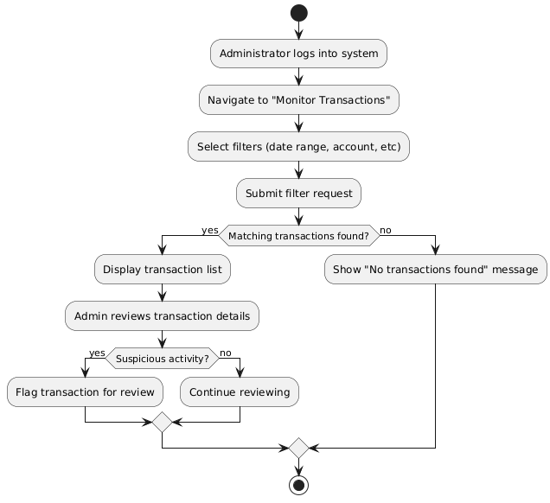

**Requirement number 14: “Administrator shall be able to freeze or close accounts.”**

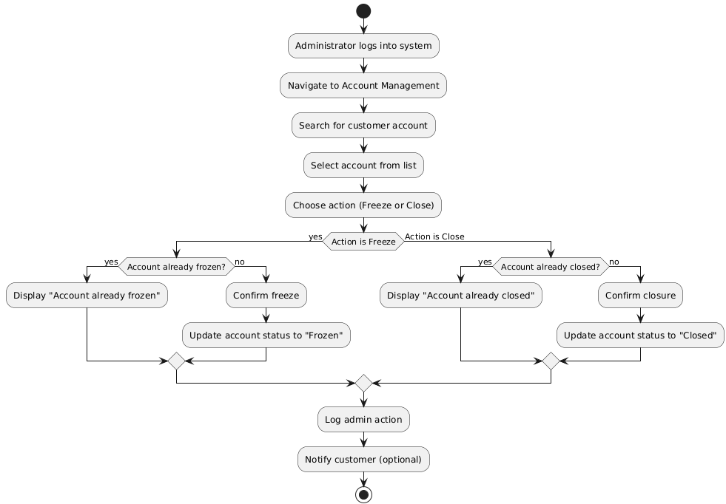

**Requirement number 15: “Administrator shall be able to generate reports on transactions.”**

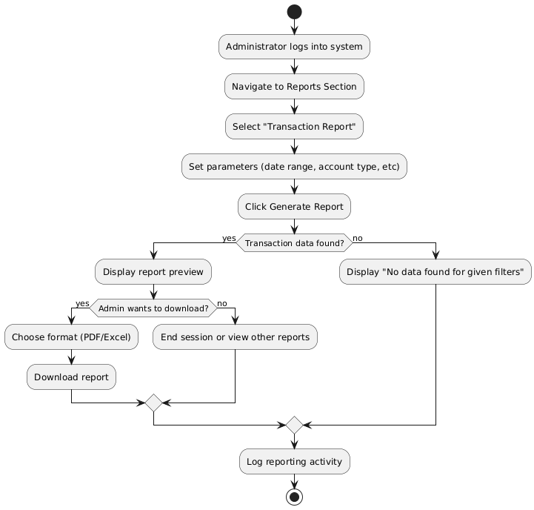

**Requirement number 16: “System shall be able to validate account details during creation.”**

